DONORS
This could be you. NDN's startup was funded by grants from the Bingham Program and the Betterment Foundation. Ongoing costs will need to be funded by donations and fund raising.
Neighbors Driving Neighbors is a 501(c)(3) organization as defined by the IRS. It offers no gifts, services, or membership benefits for contributions; thus gifts are completely tax-deductible.

HOW YOU CAN HELP

Become a volunteer driver.

Tell people in the five towns we serve who need rides to contact NDN.

Send NDN a donation.

NEIGHBORS DRIVING
NEIGHBORS (NDN)

BOARD OF DIRECTORS

Dan Onion, President
Shelly Fitzgerald, Vice President
Ellie Andrews, Treasurer
Sandy Wright, Secretary
Maggie Chadwick
Sandy Colt
Pat Onion
Pat Rawson
Tim Pike
Eunice Reneyske
Paula Thomson
Jo Tibby

CONTACT INFORMATION:

PO Box 142, Mount Vernon, ME 04352
Website:
neighborsdrivingneighbors.org
Email: neighborsdrivingneighbors@gmail.com
Phone: Coordinator Irene Goff at

860-0677

Neighbors Driving Neighbors (NDN)
FREE transportation for residents of
Belgrade, Fayette, Mount Vernon, Rome, Vienna
Do you or someone you know need a ride to shop, run errands, go to the doctor or to another place? If you live in any of the five towns listed above, our volunteer drivers will take you if the location is within 30 miles or so. Yes? Please contact NDN.
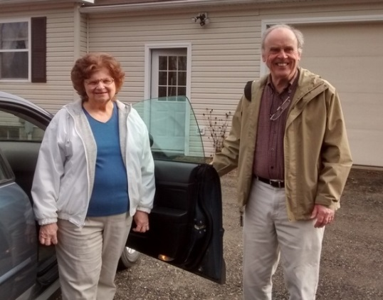

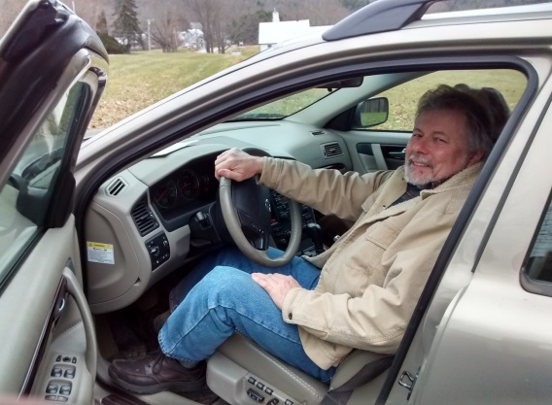

VOLUNTEER DRIVERS

The volunteers are generous neighbors who donate their time, vehicle, and gas with no compensation. All the drivers have had reference, driver and background checks to ensure the highest level of safety. NDN is looking for more people who like to drive, have a good driving record and would enjoy being part of this important effort.
Drivers say 'It is very rewarding to be able to help others directly while meeting and visiting with neighbors.” If you are interested please contact NDN.

RIDERS
NDN provides free transportation for adults for errands, exercise sessions, classes, medical appointments, shopping, socialization or volunteering. Riders have said, “It is a relief to me to know I can get a ride when I need it,” and “It is a good experience, with real country village sociability.”

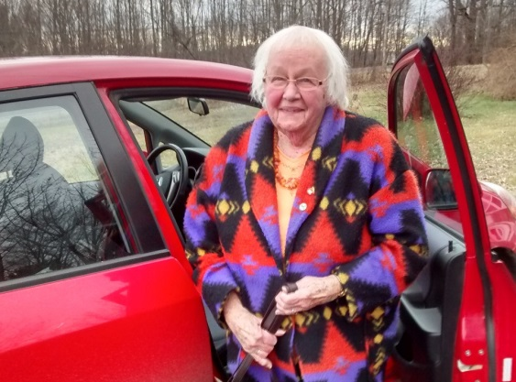

The riders are neighbors in Belgrade, Fayette, Mount Vernon, Rome, and Vienna, who cannot drive. Riders must be able to get in and out of a vehicle with minimal arm assistance. Priority will be given to those without other transportation options.

NDN’s Mission is
to enrich communities in northwestern Kennebec County by coordinating volunteer drivers who assist those who don’t drive, so they can more easily remain in their homes.
NDN’s Vision is
that central Maine communities will be a place where people of all ages are able to enjoy meaningful lives while living in their homes.
NDN’s HISTORY

- NDN began in the fall of 2012 when the Mount Vernon Community Partnership Corp. began meeting with interested people who were concerned about the lack of transportation for people who can’t drive.
- Townspeople from Belgrade, Fayette, Mount Vernon, Rome and Vienna knew how important the problem was and participated in starting the project.
- It received a planning grant from the Maine Community Foundation to hire consultants in 2014.
- It received start-up grants from The Betterment Fund and The Bingham Program in 2015.
- It hired a coordinator in 2015 and became NEIGHBORS DRIVING NEIGHBORS with its own board, bylaws, mission, and 501(c)(3) nonprofit.
- We began driving people in November 2015.

