**May 16, 2017**

**Transcript submitted to the Joint Select Committee on Marijuana Legalization Implementation**

**Representative Pierce and Senator Katz**

**Greetings I am honored to be a participant today and I thank you for your collective hard work. The theme of my presentation is that I think you need more time. I represent a community that voted against question 1 and recently considered the adoption of the Maine Municipal Association’s sample prohibition ordinance for our Annual Town Meeting that will be held next month. I am here today as the Town Manager of the Town of Fayette representing the Town and in full support of my 5 member Board of Selectmen.**

**Over the last two years, the State of Colorado has received over 150 million dollars in excise taxes as the result of over a billion dollars in sales by various State regulated marijuana businesses. So, it would seem contradictory for any town or city to oppose such an opportunity whereas Maine would greatly benefit from the new revenue. However, the sale of recreational marijuana needs to be regulated under tight control with established limits for the THC that is contained in the products that will be sold to Mainer’s.**

**In the months that followed the vote on November 8, 2016, I did not give this issue much thought other than knowing I would have to prepare options for the Town to consider in the future. That all changed, having attended the yearly Maine Town, City, County Managers Interchange on March 24th, 2017. This was an excellent and informative event that left me with a lot of concerns and questions. Since the conference, I committed the last 7 weeks to learn all that I could about the issues at work to assist my Board and my Town in its decision-making processes. One of the primary concerns I had heard at the conference was the discussion of products with increased levels of tetrahydrocannabinol (THC) which is of course the psychoactive chemical in cannabis.**

**My research interestingly and comically would lead me to find stories entitled “Not your Father’s Marijuana” or “Not Dad’s Weed”. Now, my Dad is 83 years old and I don’t think he does weed… Although twice a week he plays ice hockey at the Portland Expo with men half his age men younger than me. Soo maybe that’s his secret. Then I recognized the author’s real intent and I swallowed my pride and realized they were talking about me I am 52 I graduated high school in 1983. So, it’s my weed they were talking about.**

**I have dear friends from my school days that smoked marijuana throughout their adolescence and as adults. Today these folks continue to smoke recreationally. They are well functioning, successful, professional people contributing to society in positive ways. The cannabis they consume tops out at 3%-4% THC. In contrast, today’s edible marijuana products exceed 75% THC. Oils for “dabbing” or cooking or vaping are noted to be between 70-100% THC. That is a significant mind numbing-altering difference from “my weed” and one that I believe to be the greatest concern about the decision that was made last November.**

**Today’s cannabis increased THC products if left unregulated will lead to a negative human impact. One that will harm the people of this State and will put additional burdens on all service providers that will be called upon to respond to high THC cannabis induced issues.**

**This concern is based on the realities of the Colorado experience, where new compelling data is now revealing an increasing number of negative reports resulting from the introduction of retail/commercial recreational cannabis products with elevated THC. For decades, marijuana in the United States averaged 3-6% THC. In Colorado, the average THC in the smoking marijuana product now ranges from 18% to 25% and as mentioned previously the edible products are up to 75% and beyond with the vaporized products. It is interesting to note that** **non-smoking marijuana product sales are more desired by new marijuana consumers as they offer an opportunity for discretion in their use. Discretion albeit at 75 plus% THC! The marijuana market is adding an average of 7000 new users a day. Marijuana infused edibles and vape pens make up 45% of Colorado’s sales.**

**We must recognize that marijuana has become a consumer product. A product that is an intoxicant and although it is purported to be** **less harmful, less addictive and less likely to cause violence than alcohol, how do we keep it from becoming a problem like alcohol? Controlling the THC content is crucial toward that objective. I would submit that the comment, that marijuana less harmful, less addictive and less likely to cause violence was based on traditional marijuana of 3-6 % THC. That marijuana has been used by human beings for thousands of years. Modern technology has changed “Dads weed”.**

**The Colorado data confirms that THC related traffic fatalities increased in 2016, THC has been detected in blood samples at an increasing rate in the number of new born babies in Colorado hospitals, THC consumption by school children ages 12-17 increased in 2016 which is in conflict with a CDC report findings two years ago, THC related emergency room visits to a Pueblo Colorado hospital for the same age group increased 70% in one year from 2015-2016. Correspondingly, Colorado High Schools are reporting disciplinary actions for repeated offenses for continual cannabis use by students that lead to expulsion is also on the increase.**

**Not surprisingly, demands on public safety have increased. What is a surprise however being that violent behavior of those under the influence of elevated THC products has created an unanticipated demand for police services and presence at local hospitals and to rescue calls? The common perception that cannabis consumers are mellow clearly does not necessarily apply to those that consume today’s potent products.**

**In Maine, a transformation will take place where the 3200 at-home medical marijuana caregivers will essentially succumb to a retail commercialized marijuana industry and become part of a growing industry that could potentially rival the scope and size of the tobacco industry. An industry that will offer up a menu of cannabis product lines which contain significantly elevated levels of THC. The concern of about increased THC in the blood of newborns and adolescents and impact on brain development is a significant concern that is not getting much attention.  As the parent of a special needs child whose brain growth and cognitive capabilities were growth retarded in utero, I can personally relate to the impact that associated developmental delays can have on a family and service providers.  As a small community Town Manager I know the costs and tax consequences of providing a free public education to meet the needs of the same developmental delays that can challenge the education system.**

**I mentioned earlier that our town will be considering the prohibition ordinance. Prohibition is not a desired solution. Until and unless effective regulation is adopted to address elevated THC cannabis products our Town cannot support permitting the retail and commercial production and sale of recreational marijuana.**

**The primary reason is that the provision and response for support services and the delivery of services by all Maine public governmental, quasi-governmental and private sector entities that will be called upon to deal with the aftermath of high THC product use and abuse is too great a burden for the State of Maine if the same thing happens in Maine as it is now occurring in the State of Colorado.**

**So how do you regulate these products? To answer that question, after consulting with others in the business and familiar with the Maine Marijuana Legalization Act (MLA) I offer the following to consider below:**

* **All applicants must be inspected prior to issuance of a license to ensure there is no cultivation activity prior to authorization.**
* **All sales require testing by a Department-approved laboratory certified in accordance to rules adopted by the Department in line with nationally accepted standards- these don't exist as of today which is one major reason why this state needs to slow down.**
* **Establish a foundation to base the restriction of licensing on known supply-demand. As of right now you do not have a better understanding of supply and demand- Colorado is just learning after the fact that a market study is needed. This is just one of the lessons Maine should consider while there is time to plan fully and move forward as a State.**
* **Maine would benefit from the additional time to allow for the Department that oversees the medical program to demonstrate improvements and progress in the existing medical program in terms of an effective, reasonable regulated infrastructure, with appropriate level of staffing, so that the medical program can be a model for a large scale, statewide retail.**
* **High THC maybe needed for a patient seeking relief for a debilitating or chronic medical condition, but is not appropriate for recreational use.  Concentrates (cannabis oil), used to make cannabis infused products for the retail marijuana may not exceed 50 mg/ml. Thus, reducing the potential risk and impact that taxing on municipalities, hospital admissions, impact mental health services and local insurance rates.**
* **All packaging that marks 10mg or ml per serving with a maximum of 50 mg/ml total per product.**
* **All products sold include a warning label and labeling must include public safety messaging, warnings for dosage, THC potency, ingredients including method used for extraction. Labeling should be verified by a third party testing lab- again there is no standard there is no prescribed language at this time or any standard set for what may be considered unsafe for use/consumption which is why Maine needs to look at other states and need time to develop guidance thoughtfully. This should be one of the first steps, not an afterthought or something to be picked up along the way.**
* **Limit all retail recreational/commercial business entities per parcel by a plant count of 100 flowering plants which will greatly simplify enforcement by the state. Forget about the square footage component but yes it is necessary to think about demand for resources (time and personnel) that this or any compliance/enforcement will take.**
* **It is reasonable to think that not every voter read the initiative, but did vote to give any adult the right and protection to grow for their own personal use. This very basic and simple right has gotten lost in the other states and the same risk is here too if our state cannot effectively manage a retail market with increasingly complexity in licensing structure and the absence of inconsistent regulations before issuing authorizations for cultivation, distribution and sales. In short you will lose your right to grow, consume and carry.**
* **Consider a lottery for applicants to ensure a fair market, and allow the licensee to determine what size space they need to grow a limited number of plants, that the licensee must have primary residency in the State of Maine, that the license held by business entity to be under a single social security of a Maine resident, with all of the entity's employee and shareholders must be Maine residents.**
* **That all said there will always be creative or blatantly obvious violations to any regulation. The number of different and likely conflicting local regulations will be difficult for police to enforce to say the least and a challenge for those who want to abide by the laws.**
* **Even with regulations in place, the temptation for black market business will surely exist, for the establishments as well as any adult cultivating and possessing an unlimited amount.  The obvious loopholes include adults giving away high level marijuana for "donation", ways to be fraudulent with any required testing and labeling- as in a person could submit a product for testing and apply that to a different crop, and the ability to effectively and efficiently police to the different ordinances.**
* **The seed to sale process is one way that you can audit compliance to some level, but more is needed to ensure a "robust regulatory structure", one that addresses concerns for diversion. We cannot assume that our neighboring states are ok with Maine marijuana crossing borders, just because they have a law that allows for recreational, these laws may be very different.**
* **There needs to be outlines of a standard for product labeling and packaging, and provides education and information about marijuana- the various types of cannabis plants and their varying effects as well as the potential risks, that is appropriate for customers and be valuable to our medical providers, parents and youth.**
* **It is important that these details are worked out before we have new businesses pressuring local officials to open doors.**

**In summary as a nation, we have failed miserably with the commercialization of alcohol and tobacco. We need to be more concerned about public health and the health impacts and the public safety regarding these things and less concerned about the business revenue such industries represent. Marijuana is a part of life in Maine for many consumers.**

**Let’s keep Maine mellow and control the THC content of the recreational marijuana market.**

**The intent moving forward would be at a minimum to seek an extension of the current moratorium as I mentioned you need more time. At the most I would advocate that a rethinking of November’s vote be addressed to simply allow limited recreational use to what it is today: grow and consume your own and carry 2.5 ounces free of prosecution. In my humble opinion that is what most voters that voted in favor of question 1 really wanted.**

**Thank you for your time.**

**Respectfully Submitted,**

**Mark Robinson, Town Manager**

**Town of Fayette**

**2589 Main Street**

**Fayette Maine 04349**

**office 207-685-4373**

**cell 207-512-0949**

**facsimile 207-685-9391**

**e-mail** [**fayette@myfairpoint.net**](mailto:fayette@myfairpoint.net)

**You need more time see the graph below:**

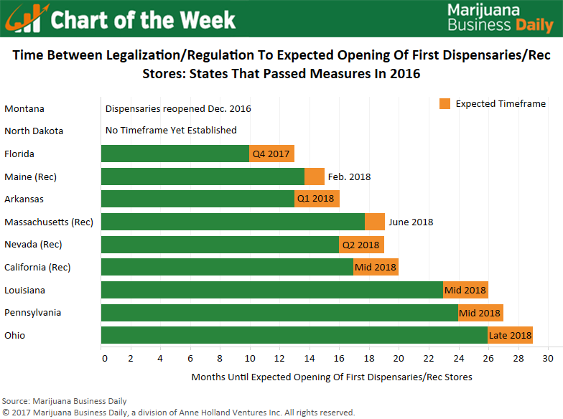

Sites to review and contacts

CBS News 60 minutes interview of Dr. Steven Simerville of Pueblo's St. Mary Corwin 719-557-4000.

Tom Wickman, Police Chief Town of Frisco Colorado [tomw@townoffrisco.com](mailto:tomw@townoffrisco.com) 970-668-8600

Jody Hensley, Massachusetts Smart Approaches to Marijuana/ [jodyshens@aol.com](mailto:jodyshens@aol.com) 508-725-5505

WGBY Boston Impact of legalized marijuana

Dr. Ruth Potee Greenfield Health 413-774-6301 [rupotee@gmail.com](mailto:rupotee@gmail.com)  
  
Source: HealthTap, <https://www.healthtap.com/experts/9200277>

Smart approaches to marijuana

Dr. Christian Thurstone 970-668-8600

KEYT Special : Politics of POT published on October 31, 2016

CBS News Big Pot the Commercial Take Over published on November 6, 2016

<http://marijuana-policy.org/?s=Revenue&submit=Search>

<http://bostonalliance.org/wp-content/uploads/2013/02/plausibleRisk.pdf>

<http://marijuana-policy.org/?s=Precautionary&submit=Search>

Marijuana Use Increases Violent Behavior | Psychology Today  
<https://www.google.com/amp/s/www.psychologytoday.com/blog/the-new-brain/201603/marijuana-use-increases-violent-behavior%3Famp>

Medical Marijuana Caregivers of Maine [(207)596-3501](tel:(207)%20596-3501)  
[Info@mmcm-online.org](mailto:Info@mmcm-online.org)  
[www.mmcm-online.org](http://www.mmcmonline.org)

Kevin Kafka Canacare [kevin@cannacaredocs.com](mailto:kevin@cannacaredocs.com) 303-883-1147

See additional packet .

